I. Show instructor name only.
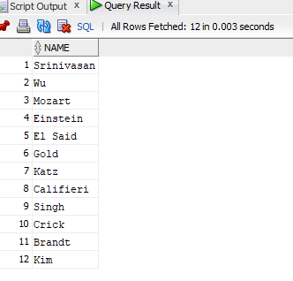
II. Show course id and title only.
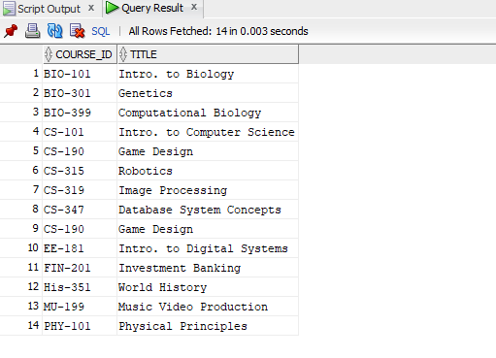

III. Find instructor name and department of the instructor with id = 22222.
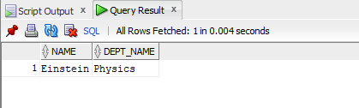
IV. Find course title and credits of the courses offered by ‘Comp. Sci.’ department.
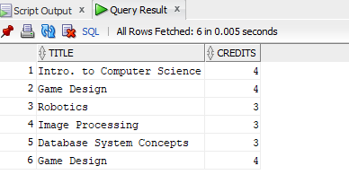
V. Find name and department of instructors who have a salary more than 70000.
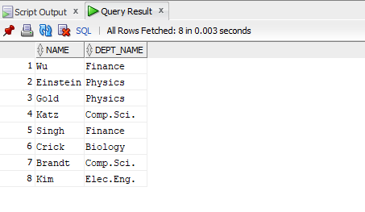
VI. Find course title of the courses which are not less than 4 credits.
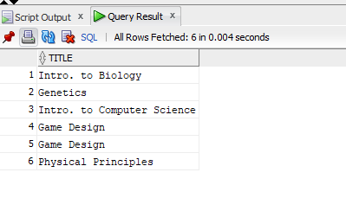
VII. Find name and department of instructors who have a salary in between 80000 and 100000 (bounds are inclusive).
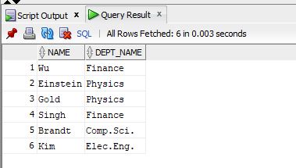

VIII. Find course titles and credits of the courses not offered by ‘Comp. Sci.’ department.
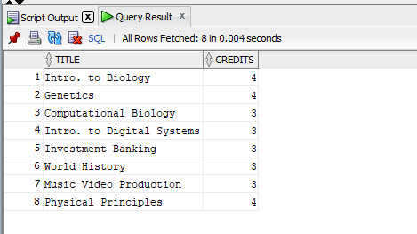
IX. Display all records of instructor table.
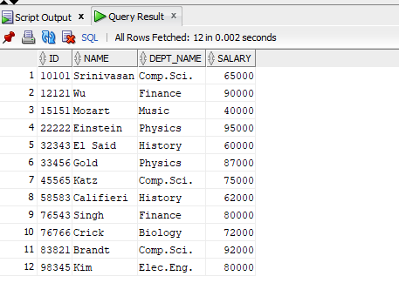

X. Find all courses (display all columns) which are offered by ‘Biology’ department and credits is not 4.
